**PERIYAR UNIVERSITY**

|  |  |
| --- | --- |
| **PROJECT TITLE** | **UNVEILING MARKET INSIGHTS :ANALYSING SPENDING BEHAVIOUR AND IDENTIFYING OPPORTUNITIES FOR GROWTH** |

|  |  |
| --- | --- |
| **Team id: NM2023TMID22575** | |
| **Student Name** | **Student NM Id** |
| AADHAVAN M | 9209B2C02A3C5A4899F4C54A685CA4A1 |
| ARULKUMAR R | EBB55B4A7865FF3ADBB4B292B97FF6B3 |
| DHANUSHU K | D8A4D13008EFF1F9B214A27F38F9078D |
| PURUSHOTHAMAN U | D85F277681E7E9D87EE452CDC267C1C8 |

**INCHARGE: Mr. K. CHINNAIYA, M.Sc., M.Ed., M.Phil.,**

**III-BSc Mathematics (2023-2024)**

**DEPARTMENT OF MATHEMATICS**

**101-ARIGNAR ANNA GOVERNMENT ARTS COLLEGE, ATTUR**







* **INTRODUCTION :**

Wholesaling or distributing is the sale of goods  to retailer to

* [**industrial**](https://en.wikipedia.org/wiki/Manufacturing)**,**
* commercial,
* [institutional](https://en.wikipedia.org/wiki/Institutional) or other professional businessman to other wholesalers (wholesale businesses) and related subordinated services.
  + - Wholesaling is buying goods in bulk quantity, usually directly from the manufacturer or source, at a discounted rate.
    - The retailer then sells the goods to the end consumer at a higher price making a profit.
    - The consumption and production of marketed food are spatially separated.
    - Production is primarily in rural areas while consumption is mainly in urban areas.
    - In today's highly competitive business landscape, gaining deep market insights is essential for businesses to thrive and grow.
    - This project aims to analyze customer spending behavior and identify opportunities for growth by leveraging data analytics and data-driven decision-making.
    - The primary objective of this project is to understand customer spending patterns, preferences, and trends across various dimensions.
    - By conducting a comprehensive analysis,
    - businesses can optimize their marketing strategies,
    - improve product offerings, and
    - enhance customer engagement to drive revenue growth.
* **PROBLEM DEFINITION AND DESIGN THINKING:**

**2.1 EMPATHY MAP:**

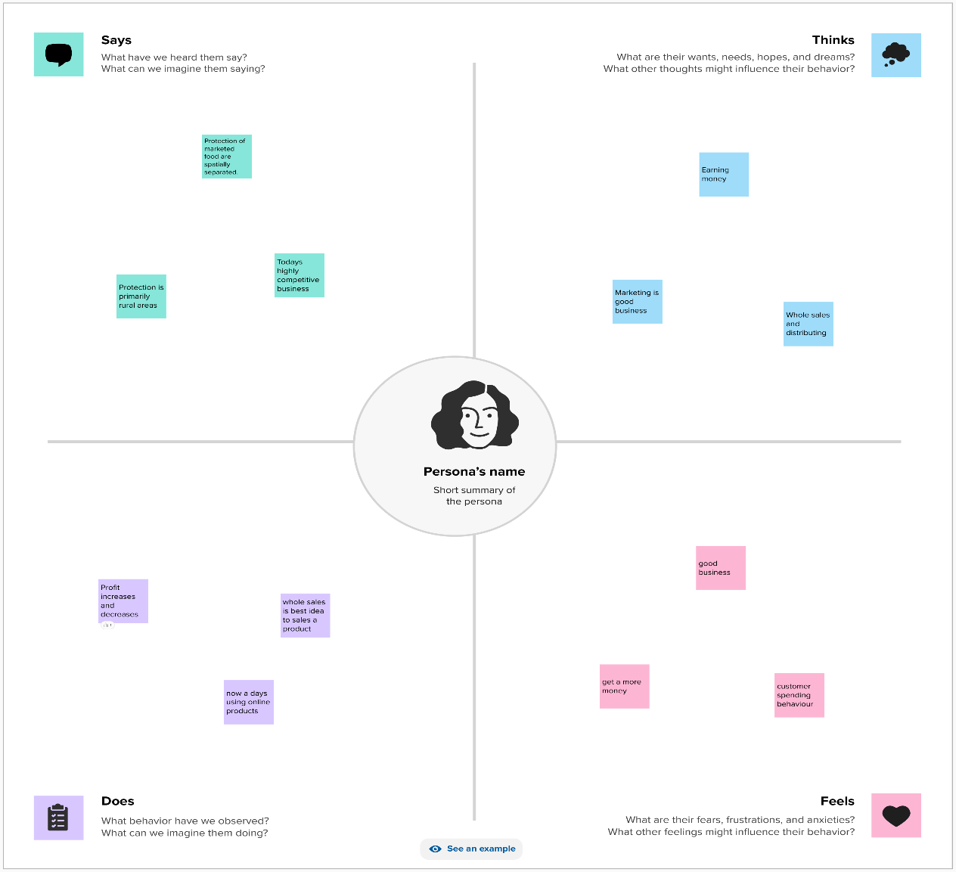

**2.2 BRAINSTROMING:**

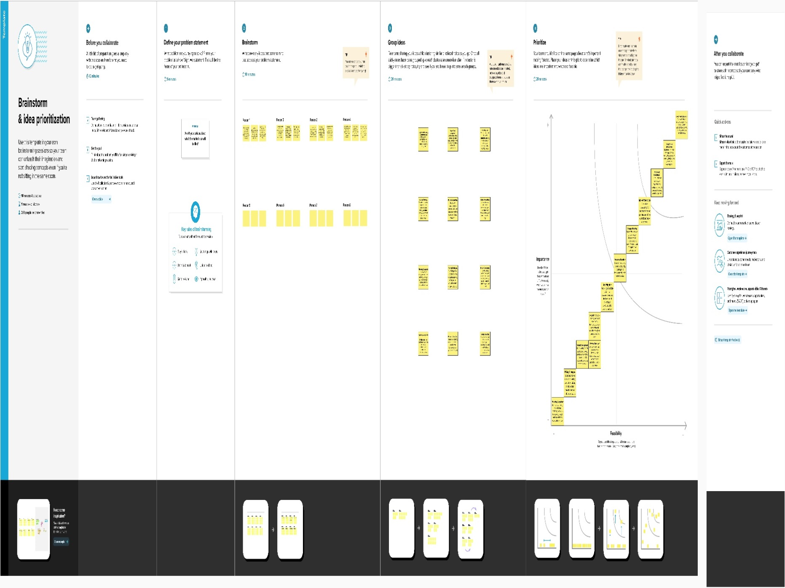

**RESULT:**

**2.1 DASHBOARD:**

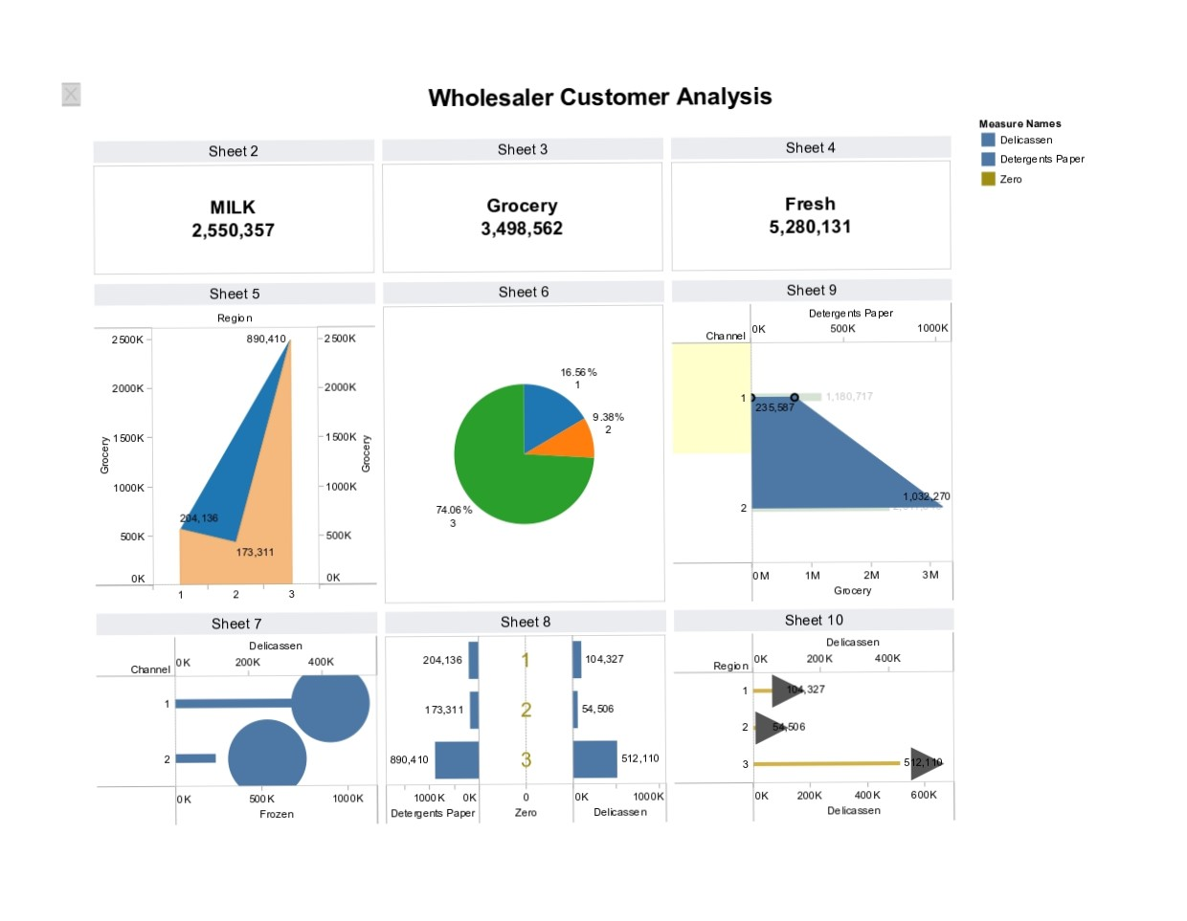

**3.2 STORY :**

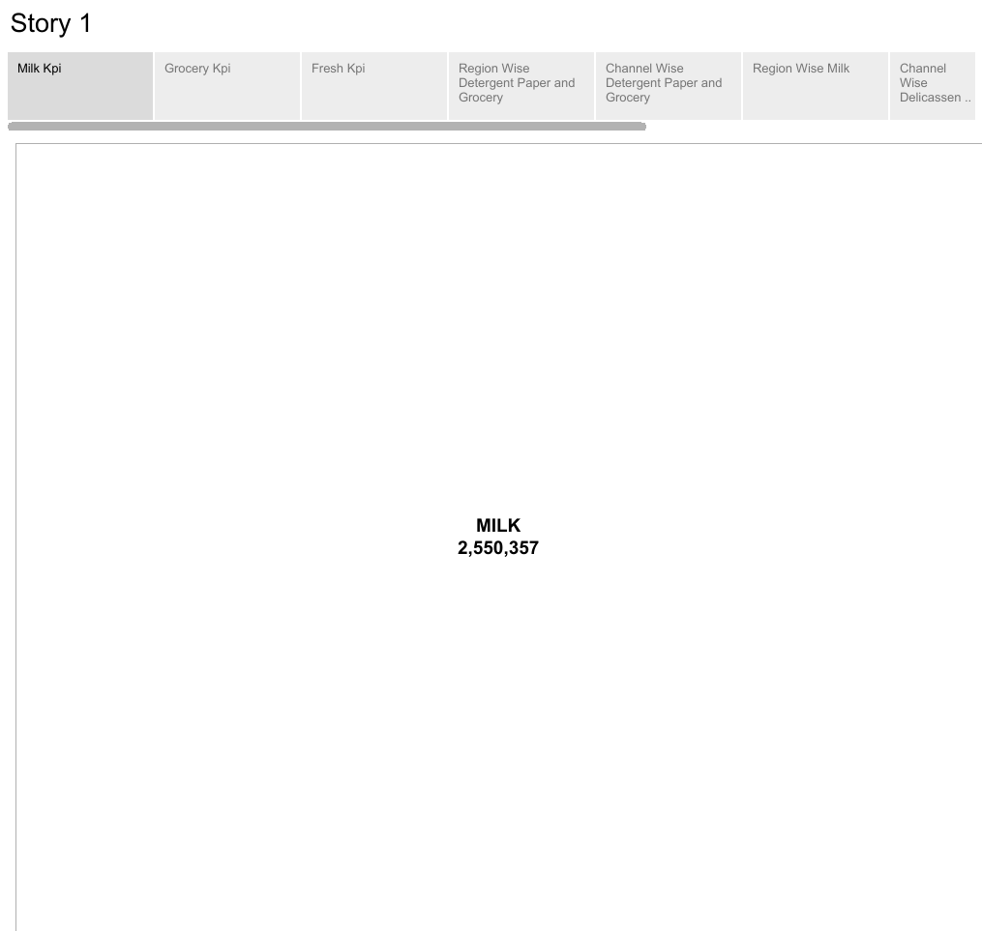

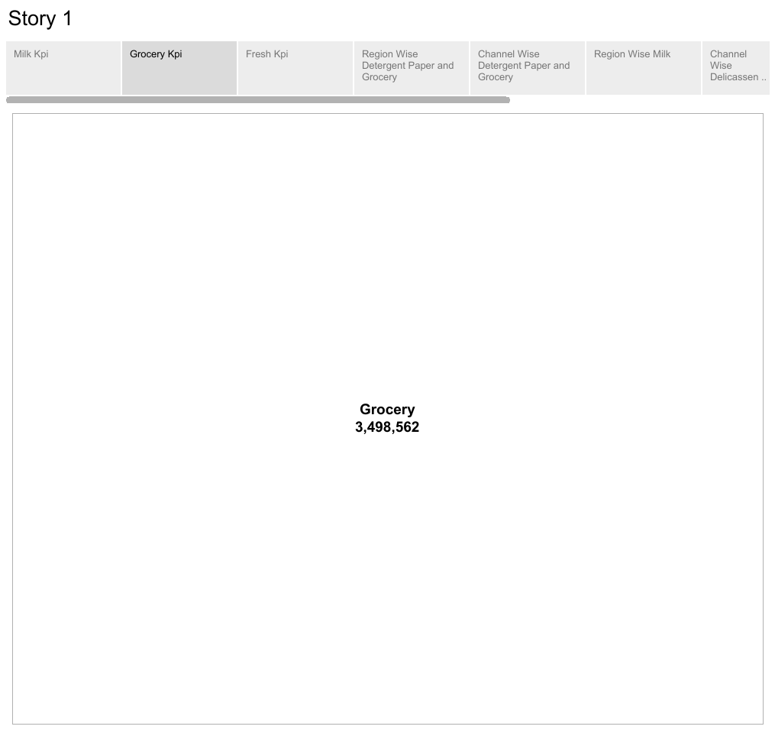

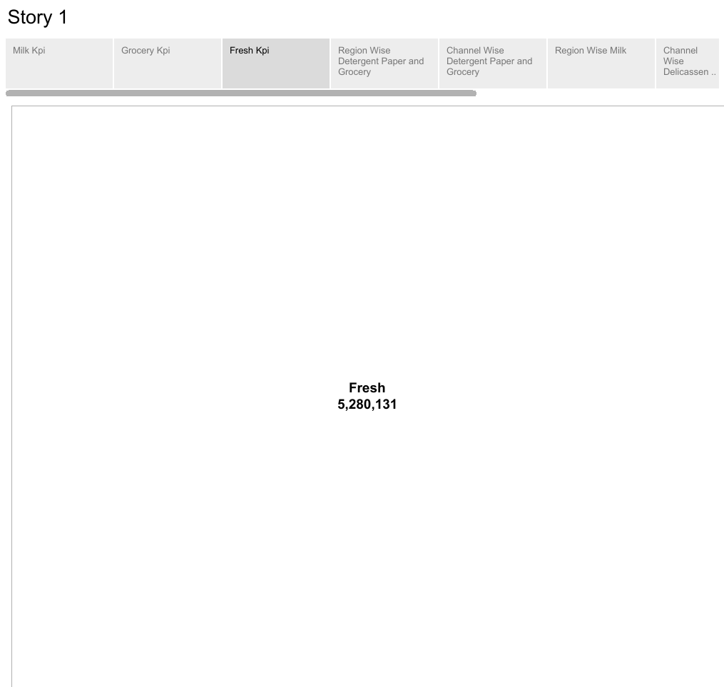

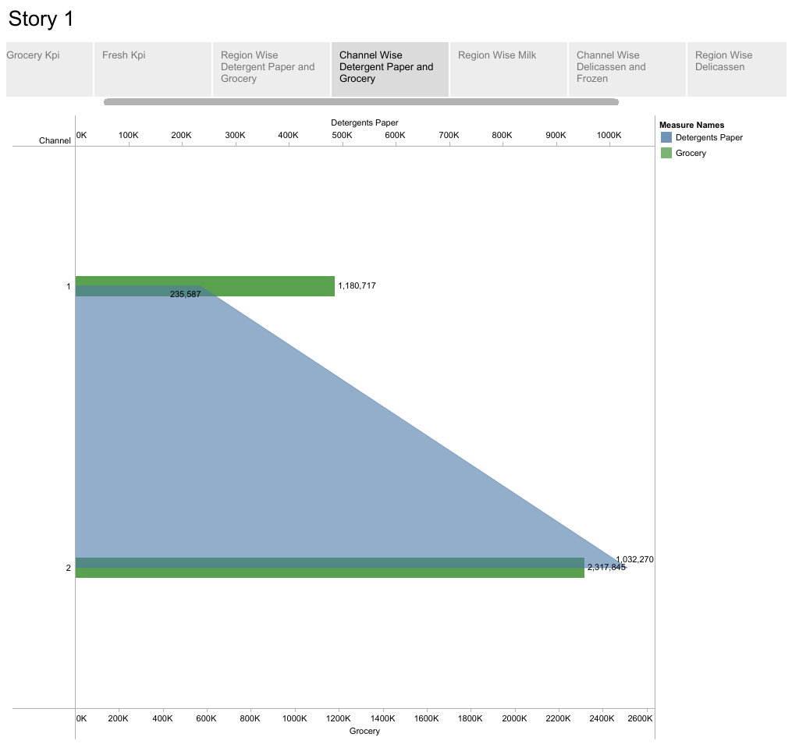

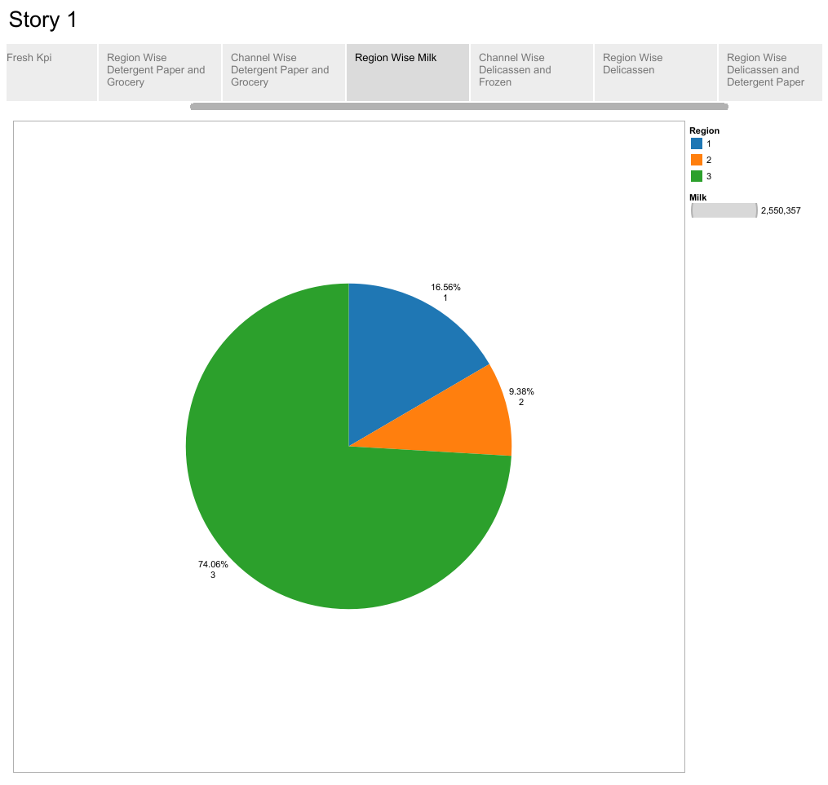

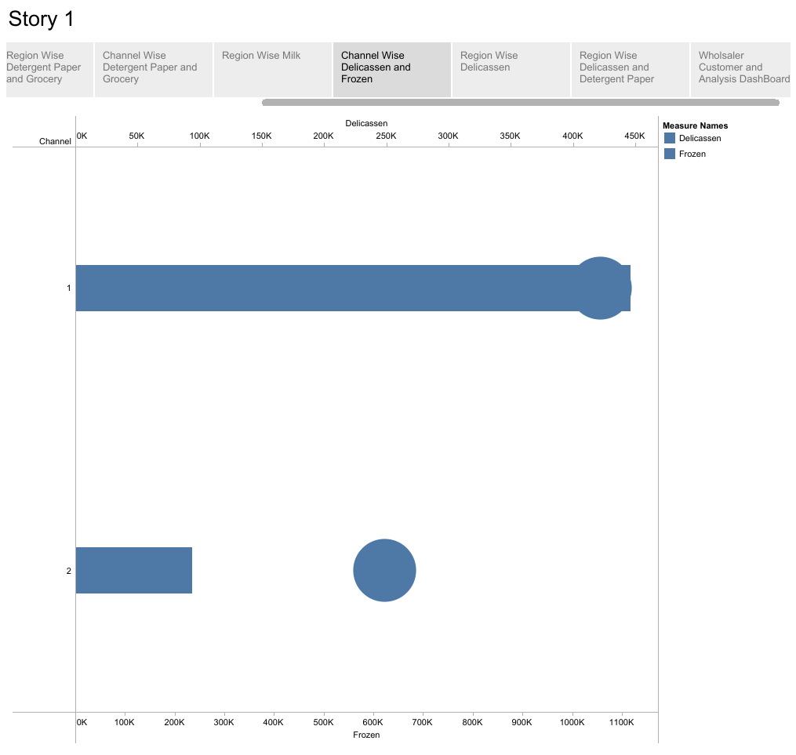

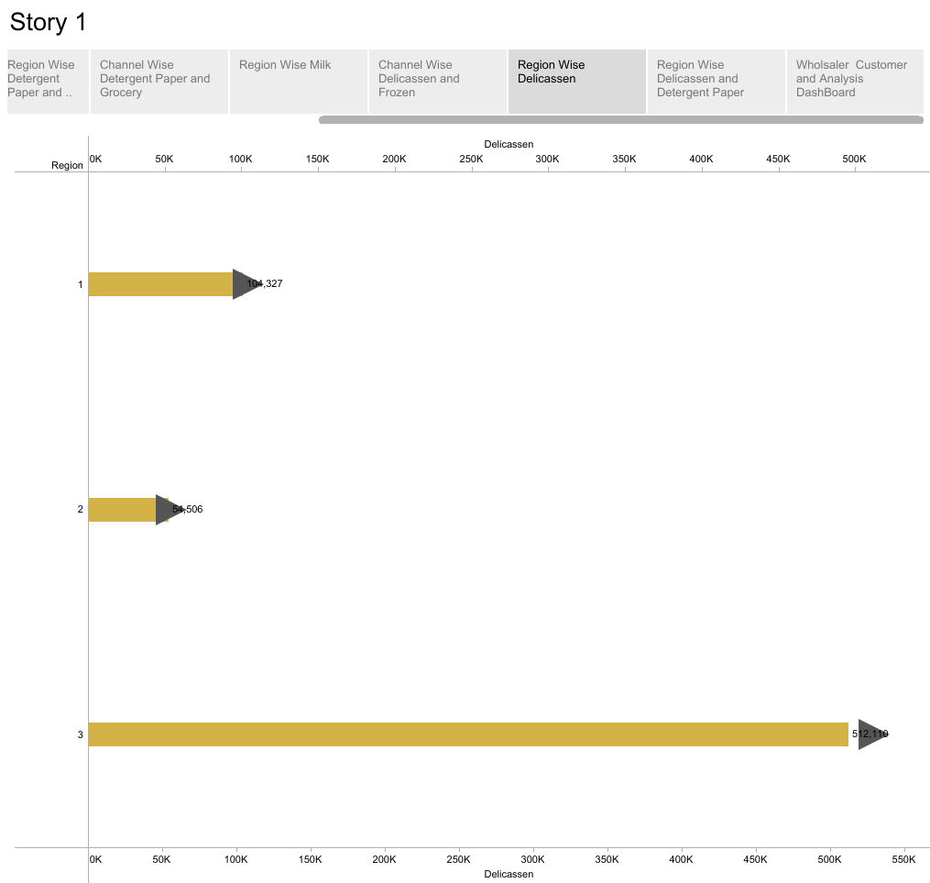

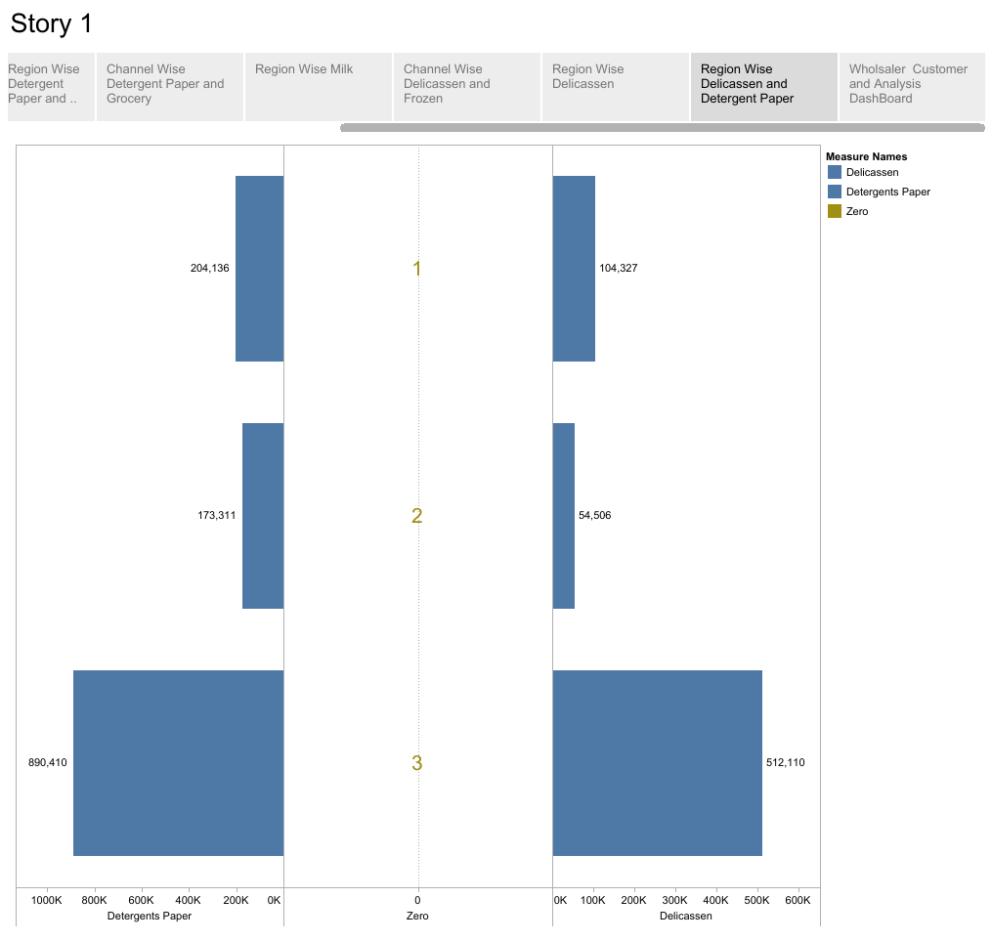

**ADVANTAGES AND DISADVANTAGES :**

**4.1 ADVANTAGES :**

1. **Identifying trends and patterns:** Analyzing spending behavior can help businesses identify trends and patterns in consumer purchasing habits. This can aid in understanding consumer preferences, predicting future demand, and making informed business decisions.

2. **Understanding customer segments**: Market insights can provide valuable information about different customer segments. By analyzing spending behavior, businesses can gain insights into the demographics, preferences, and needs of their target audience. This can help in developing targeted marketing campaigns and tailored product offerings to better serve specific customer segments.

3. **Improving customer experience**: By analyzing spending behavior, businesses can gain insights into the customer journey and identify pain points or areas for improvement. This allows businesses to enhance the customer experience, such as by addressing customer concerns, streamlining processes, or offering personalized recommendations.

4**. Optimizing pricing and promotions** :Market insights can help businesses understand how price-sensitive customers are and how they respond to different promotions or discounts. By analyzing spending behavior, businesses can optimize pricing strategies and promotional offers to maximize sales and profitability.

5. **Competitor analysis**: Market insights can provide valuable information about competitors' strategies and performance. By analyzing spending behavior, businesses can gain insights into market share, pricing strategies, and customer preferences of their competitors.

**4.2 DISADVANTAGES :**

1**) Limited data accuracy:** Market insights are typically based on data collected from surveys, focus groups, or purchase transactions. However, these data sources may not always accurately reflect actual spending behavior. People may provide biased or incomplete information in surveys, and focus groups may not represent the broader population. Similarly, purchase transaction data might not capture spending patterns accurately if there are errors or inconsistencies in recording the data.

2**) Lack of context:** Analyzing spending behavior alone may not provide a complete picture of market insights. It is essential to understand the underlying reasons for the observed spending patterns. Without additional contextual information, such as consumer preferences, market trends, or economic factors, the insights derived from spending behavior analysis may be incomplete or misleading.

3**) Inadequate sample size**: The reliability of market insights heavily depends on the sample size and its representativeness. If the sample size is too small or not diverse enough, the insights derived from analyzing spending behavior may not be generalizable to the entire target audience. It is essential to have a sufficiently large and diverse sample to ensure meaningful and reliable insights.

4**) Difficulty in predicting future behavior**: Analyzing past spending behavior may not always provide accurate predictions of future behavior. Consumer preferences and market conditions can change rapidly, making it challenging to extrapolate future spending patterns based solely on historical data. External factors like economic downturns, new product introductions, or changes in consumer sentiment can significantly impact consumer spending behavior.

5) **Ethical concerns**: Analyzing spending behavior often involves the collection and analysis of sensitive personal data. Maintaining consumer privacy and ensuring data security is crucial in these analyses. Companies must adhere to strict ethical standards and legal regulations to protect consumer information and maintain trust.

**APPLICATIONS :**

1) **Targeted marketing strategies**: By analyzing spending behavior, businesses can identify specific customer segments and understand their preferences, interests, and buying habits. This insight allows companies to create targeted marketing campaigns that resonate with their target audience and enhance customer engagement and loyalty.

2) **Product development and improvement**: Studying spending behavior can help businesses identify gaps in the market and uncover emerging trends. By analyzing how customers spend their money, companies can develop or improve products and services to meet customer needs and preferences more effectively.

3) **Pricing strategies**: Understanding spending behavior can help businesses determine optimal pricing strategies. By analyzing how customers respond to different price points and identifying price sensitivity, companies can set competitive prices that maximize revenue and customer satisfaction.

4**) Competitive analysis**: Analyzing spending behavior across different consumer segments can provide insights into the competitive landscape. By understanding how customers distribute their spending across various competitors, businesses can identify their comparative advantages and weaknesses and develop strategies to gain a competitive edge.

5) **Customer retention and loyalty:** Spending behavior analysis can help identify key factors that drive customer loyalty and retention. By understanding what influences customers to continue spending with a particular company, businesses can take targeted actions to enhance customer satisfaction, such as personalized offers, rewards programs.

**CONCLUSION :**

In conclusion, while analyzing spending behavior can provide useful market insights, there are several limitations and challenges to consider. Accurate data collection, contextual understanding, sample representativeness, prediction challenges, and ethical considerations are essential factors to address when unraveling market insights through spending behavior analysis.

Combining spending behavior analysis with other research methods and contextual information can lead to more comprehensive and reliable market insights.

**EMBED CODE :**

**7.1 DASHBOARD EMBED CODE :**

<div class='tableauPlaceholder' id='viz1696834147025' style='position: relative'><noscript><a href='#'><img alt='Wholesaler Customer Analysis ' src='https:&#47;&#47;public.tableau.com&#47;static&#47;images&#47;Da&#47;DashboardI_16968339969200&#47;Dashboard1&#47;1_rss.png' style='border: none' /></a></noscript><object class='tableauViz' style='display:none;'><param name='host_url' value='https%3A%2F%2Fpublic.tableau.com%2F' /> <param name='embed_code_version' value='3' /> <param name='site_root' value='' /><param name='name' value='DashboardI_16968339969200&#47;Dashboard1' /><param name='tabs' value='no' /><param name='toolbar' value='yes' /><param name='static_image' value='https:&#47;&#47;public.tableau.com&#47;static&#47;images&#47;Da&#47;DashboardI_16968339969200&#47;Dashboard1&#47;1.png' /> <param name='animate_transition' value='yes' /><param name='display_static_image' value='yes' /><param name='display_spinner' value='yes' /><param name='display_overlay' value='yes' /><param name='display_count' value='yes' /><param name='language' value='en-US' /><param name='filter' value='publish=yes' /></object></div> <script type='text/javascript'> var divElement = document.getElementById('viz1696834147025'); var vizElement = divElement.getElementsByTagName('object')[0]; if ( divElement.offsetWidth > 800 ) { vizElement.style.width='1100px';vizElement.style.minHeight='827px';vizElement.style.maxHeight='2427px';vizElement.style.height=(divElement.offsetWidth*0.75)+'px';} else if ( divElement.offsetWidth > 500 ) { vizElement.style.width='1100px';vizElement.style.minHeight='827px';vizElement.style.maxHeight='2427px';vizElement.style.height=(divElement.offsetWidth*0.75)+'px';} else { vizElement.style.width='100%';vizElement.style.height='2777px';} var scriptElement = document.createElement('script'); scriptElement.src = 'https://public.tableau.com/javascripts/api/viz_v1.js'; vizElement.parentNode.insertBefore(scriptElement, vizElement); </script>

**7.2 STORY EMBED CODE :**

<div class='tableauPlaceholder' id='viz1696835121387' style='position: relative'><noscript><a href='#'><img alt='Story 1 ' src='https:&#47;&#47;public.tableau.com&#47;static&#47;images&#47;Da&#47;DashboardI_16968339969200&#47;Story1&#47;1_rss.png' style='border: none' /></a></noscript><object class='tableauViz' style='display:none;'><param name='host_url' value='https%3A%2F%2Fpublic.tableau.com%2F' /> <param name='embed_code_version' value='3' /> <param name='site_root' value='' /><param name='name' value='DashboardI_16968339969200&#47;Story1' /><param name='tabs' value='no' /><param name='toolbar' value='yes' /><param name='static_image' value='https:&#47;&#47;public.tableau.com&#47;static&#47;images&#47;Da&#47;DashboardI_16968339969200&#47;Story1&#47;1.png' /> <param name='animate_transition' value='yes' /><param name='display_static_image' value='yes' /><param name='display_spinner' value='yes' /><param name='display_overlay' value='yes' /><param name='display_count' value='yes' /><param name='language' value='en-US' /><param name='filter' value='publish=yes' /></object></div> <script type='text/javascript'>